**LEARNING PROXIMITY RELATIONS FOR FEATURE SELECTION**

**MODULES**:

1. USER INTERFACE DESIGN:

2. FILE UPLOADING:

3. STORED IN DATABASE:

**MODULE DESCRIPTION**:

1.User Interface Design:

To connect with server user must give their username and password then only they can able to connect the server. If the user already exits directly can login into the server else user must register their details such as username, password and Email id, into the server. Server will create the account for the entire user to maintain upload and download rate. Name will be set as user id. Logging in is usually used to enter a specific page.

**MODULES DIAGRAM:**

* **User Interface Design**

Login

Server

Welcome to Login

Register

New user

Database

Welcome Page

Developer

Application

Registration

Page

Login

Server

Database

Welcome Page

Developer

Application

Registration

Page

Login

Server

Database

Welcome Page

Developer

Application

Registration

Page

Login

Server

Database

Welcome Page

Developer

Application

Registration

Page

Login

Server

Database

Welcome Page

Developer

Application

Registration

Page

Login

Server

**INPUT EXPECTED OUTPUT**

**User Interface Design**:

**Input**:

Developer Login name and Password

**Output**:

If Valid Developer Open the user window otherwise error page.

**Coding**:

package com.Servlet;

import java.io.IOException;

import javax.servlet.ServletException;

import javax.servlet.annotation.WebServlet;

import javax.servlet.http.HttpServlet;

import javax.servlet.http.HttpServletRequest;

import javax.servlet.http.HttpServletResponse;

import javax.servlet.http.HttpSession;

import com.Bean.Bean;

import com.Implementation.Implementation;

import com.Interface.Interface;

/**

* Servlet implementation class Login

*/

@WebServlet("/Login")

public class Login extends HttpServlet {

private static final long serialVersionUID = 1L;

/**

* Default constructor.

*/

public Login() {

// TODO Auto-generated constructor stub

}

/**

* @see HttpServlet#doGet(HttpServletRequest request, HttpServletResponse response)

*/

protected void doGet(HttpServletRequest request, HttpServletResponse response) throws ServletException, IOException {

// TODO Auto-generated method stub

}

/**

* @see HttpServlet#doPost(HttpServletRequest request, HttpServletResponse response)

*/

protected void doPost(HttpServletRequest request, HttpServletResponse response) throws ServletException, IOException {

HttpSession session=request.getSession(false);

response.setContentType("text/html");

String username=request.getParameter("username");

String password=request.getParameter("password");

session.setAttribute("username", username);

System.out.println("username="+username);

System.out.println("password="+password);

Bean b=new Bean();

b.setUsername(username);

b.setPassword(password);

Interface i=new Implementation();

boolean m=i.login(b);

System.out.println("m="+m);

if(m==true)

{

response.sendRedirect("fileupload.jsp");

}

else

{

response.sendRedirect("missmatch.jsp");

}

}

}

package com.Servlet;

import java.io.IOException;

import javax.servlet.ServletException;

import javax.servlet.annotation.WebServlet;

import javax.servlet.http.HttpServlet;

import javax.servlet.http.HttpServletRequest;

import javax.servlet.http.HttpServletResponse;

import com.Bean.Bean;

import com.Implementation.Implementation;

import com.Interface.Interface;

/**

* Servlet implementation class Register

*/

@WebServlet("/Register")

public class Register extends HttpServlet {

private static final long serialVersionUID = 1L;

/**

* Default constructor.

*/

public Register() {

// TODO Auto-generated constructor stub

}

/**

* @see HttpServlet#doGet(HttpServletRequest request, HttpServletResponse response)

*/

protected void doGet(HttpServletRequest request, HttpServletResponse response) throws ServletException, IOException {

// TODO Auto-generated method stub

}

/**

* @see HttpServlet#doPost(HttpServletRequest request, HttpServletResponse response)

*/

protected void doPost(HttpServletRequest request, HttpServletResponse response) throws ServletException, IOException {

String username=request.getParameter("username");

String email=request.getParameter("email");

String password=request.getParameter("password");

String confirmpassword=request.getParameter("confirmpassword");

String gender=request.getParameter("gender");

String mobile=request.getParameter("mobile");

String address=request.getParameter("address");

System.out.println("username="+username);

System.out.println("email="+email);

System.out.println("password="+password);

System.out.println("confirmpasword="+confirmpassword);

System.out.println("gender="+gender);

System.out.println("mobile="+mobile);

System.out.println("address="+address);

Bean b=new Bean();

b.setUsername(username);

b.setEmail(email);

b.setPassword(password);

b.setConfirmpassword(confirmpassword);

b.setGender(gender);

b.setMobile(mobile);

b.setAddress(address);

Interface i=new Implementation();

int k=i.register(b);

System.out.println("k="+k);

if(k==1)

{

response.sendRedirect("login.jsp");

}

else

{

response.sendRedirect("registerfail.jsp");

}

}

}

}

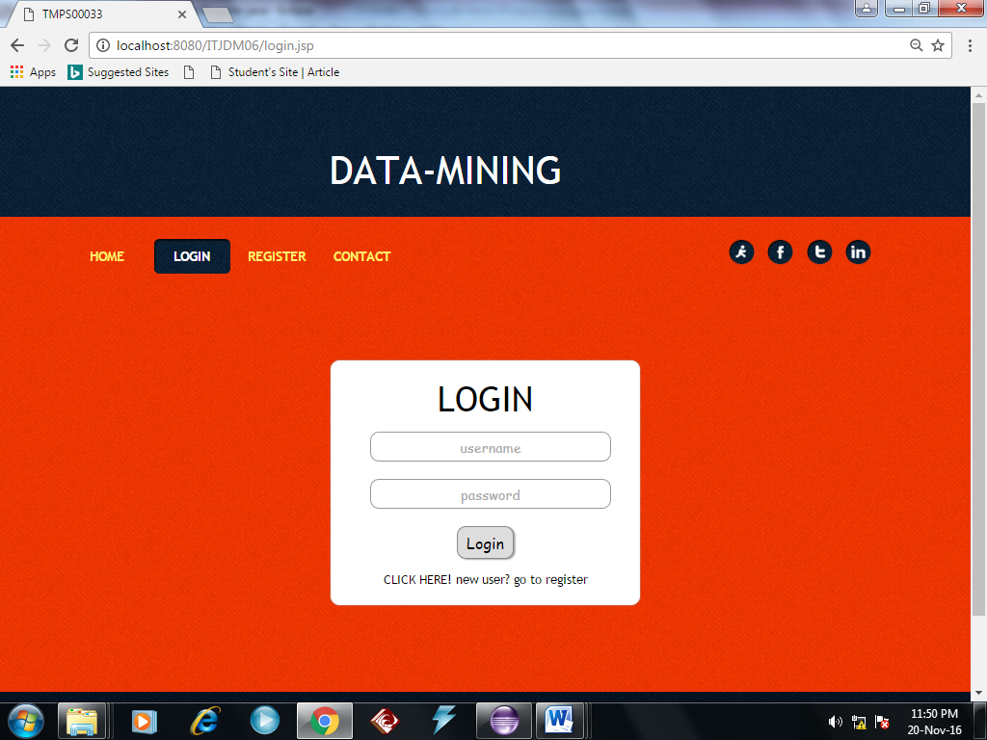

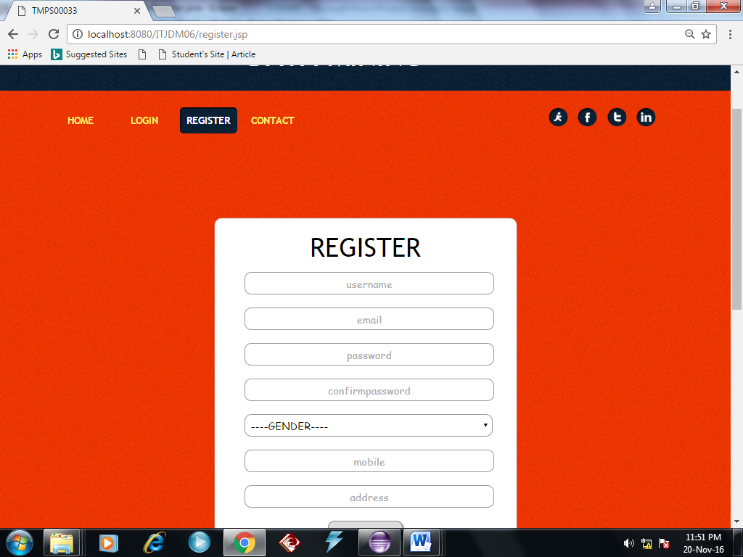

**MODULES:**

2. FILE UPLOADING:

**MODULE DESCRIPTION**:

In this module the user logged in, then user are going to upload their file

**MODULE DIAGRAM:**

**2.FILE UPLOADING:**

**user login A.txt**

**Input**:

User uploading a file.

**Output**:

The file will be stored in database.

**Coding**:

package com.Servlet;

import java.io.File;

import java.io.FileInputStream;

import java.io.IOException;

import javax.servlet.ServletException;

import javax.servlet.annotation.WebServlet;

import javax.servlet.http.HttpServlet;

import javax.servlet.http.HttpServletRequest;

import javax.servlet.http.HttpServletResponse;

import javax.servlet.http.HttpSession;

import org.apache.poi.hwpf.HWPFDocument;

import org.apache.poi.hwpf.extractor.WordExtractor;

import com.itextpdf.text.pdf.PdfReader;

import com.itextpdf.text.pdf.parser.PdfTextExtractor;

import com.Bean.Uploadbean;

import com.Implementation.Implementation;

import com.Interface.Interface;

import com.oreilly.servlet.multipart.FilePart;

import com.oreilly.servlet.multipart.MultipartParser;

import com.oreilly.servlet.multipart.Part;

/**

* Servlet implementation class Fileupload

*/

@WebServlet("/Fileupload")

public class Fileupload extends HttpServlet {

private static final long serialVersionUID = 1L;

/**

* @see HttpServlet#HttpServlet()

*/

public Fileupload() {

super();

// TODO Auto-generated constructor stub

}

/**

* @see HttpServlet#doGet(HttpServletRequest request, HttpServletResponse response)

*/

protected void doGet(HttpServletRequest request, HttpServletResponse response) throws ServletException, IOException {

// TODO Auto-generated method stub

}

/**}

* @see HttpServlet#doPost(HttpServletRequest request, HttpServletResponse response)

*/

protected void doPost(HttpServletRequest request, HttpServletResponse response) throws ServletException, IOException {

HttpSession session=request.getSession(false);

response.setContentType("text/html");

String username=request.getSession().getAttribute("username").toString();

MultipartParser mp=new MultipartParser(request,999999);

Part part;

FilePart filepart;

String filename=null;

long size=0;

String filetype=null;

String filecontent = "";

FileInputStream fis = null;

String path=getServletContext().getRealPath("");

System.out.println(path);

String editpath=path.substring(0,path.indexOf("."));

System.out.println(editpath);

String fullpath=editpath+"ITJDM06\\WebContent\\local\\";

System.out.println(fullpath);

while((part=mp.readNextPart())!=null)

{

if(part.isFile())

{

filepart=(FilePart)part;

filename=filepart.getFileName();

System.out.println(filename);

fullpath=fullpath+filename;

System.out.println(fullpath);

File file=new File(fullpath);

size=filepart.writeTo(file);

System.out.println(size);

filetype=filepart.getContentType();

System.out.println(filetype);

fis = new FileInputStream(file);

if (filename.endsWith(".txt")) {

byte[] b = new byte[fis.available()];

fis.read(b);

String reading = new String(b);

filecontent = filecontent + reading;

System.out.println("txtttttttttttttttttt==="+filecontent);

}

// reading pdf content

else if (filename.endsWith(".pdf")) {

String text = "";

com.itextpdf.text.pdf.PdfReader pdfReader = new PdfReader(fullpath);

int pages = pdfReader.getNumberOfPages();

for (int i1 = 1; i1 < pages; i1++) {

text = PdfTextExtractor.getTextFromPage(pdfReader, i1);

System.out.println("page:" + i1 + " " + text);

filecontent = text;

System.out.println("pdffffffffffff==="+filecontent);

}

// reading doc content

} else if (filename.endsWith(".doc")) {

WordExtractor extractor = null;

FileInputStream fis2 = new FileInputStream(fullpath);

System.out.println("file is" + fis);

HWPFDocument document = new HWPFDocument(fis2);

extractor = new WordExtractor(document);

String mydate = extractor.getTextFromPieces();

System.out.println("THE MYYYYYYYYYYY " + mydate);

System.out.println("doc=============="+filecontent);

}

}

}

Uploadbean up=new Uploadbean();

up.setUsername(username);

up.setFilename(filename);

up.setFiletype(filetype);

up.setFilesize(String.valueOf(size));

up.setFilecontent(filecontent);

Interface i=new Implementation();

int j=i.upload(up,username);

System.out.println("insert>>>>>>============>>>>>>>>>>>>>>>>>>>"+j);

if(j==1)

{

response.sendRedirect("success.jsp");

}

else

{

response.sendRedirect("unsuccess.jsp");

}}}

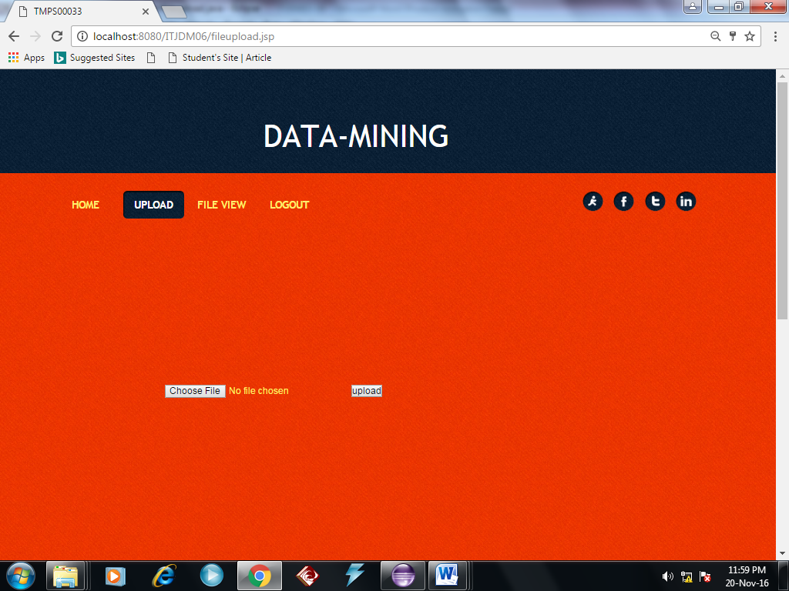

**MODULES**:

3. STORED IN DATABASE:

**MODULE DESCRIPTION:**

3. STORED IN DATABASE:

In this module, the user uploading all the file where stored in the database. The user retrieve the information from database.

**MODULE DIAGRAM:**

**3. STORE IN THE DATABASE :**

**User login A.txt file Database**

**INPUT EXPECTED OUTPUT**

**3. STORE IN THE DATABASE :**

**Input**:

User uploading the file all are stored in the database.

**Output**:

File are stored in the database.

**Coding**:

package com.Servlet;

import java.io.File;

import java.io.FileInputStream;

import java.io.IOException;

import javax.servlet.ServletException;

import javax.servlet.annotation.WebServlet;

import javax.servlet.http.HttpServlet;

import javax.servlet.http.HttpServletRequest;

import javax.servlet.http.HttpServletResponse;

import javax.servlet.http.HttpSession;

import org.apache.poi.hwpf.HWPFDocument;

import org.apache.poi.hwpf.extractor.WordExtractor;

import com.itextpdf.text.pdf.PdfReader;

import com.itextpdf.text.pdf.parser.PdfTextExtractor;

import com.Bean.Uploadbean;

import com.Implementation.Implementation;

import com.Interface.Interface;

import com.oreilly.servlet.multipart.FilePart;

import com.oreilly.servlet.multipart.MultipartParser;

import com.oreilly.servlet.multipart.Part;

/**

* Servlet implementation class Fileupload

*/

@WebServlet("/Fileupload")

public class Fileupload extends HttpServlet {

private static final long serialVersionUID = 1L;

/**

* @see HttpServlet#HttpServlet()

*/

public Fileupload() {

super();

// TODO Auto-generated constructor stub

}

/**

* @see HttpServlet#doGet(HttpServletRequest request, HttpServletResponse response)

*/

protected void doGet(HttpServletRequest request, HttpServletResponse response) throws ServletException, IOException {

// TODO Auto-generated method stub

}

/**}

* @see HttpServlet#doPost(HttpServletRequest request, HttpServletResponse response)

*/

protected void doPost(HttpServletRequest request, HttpServletResponse response) throws ServletException, IOException {

HttpSession session=request.getSession(false);

response.setContentType("text/html");

String username=request.getSession().getAttribute("username").toString();

MultipartParser mp=new MultipartParser(request,999999);

Part part;

FilePart filepart;

String filename=null;

long size=0;

String filetype=null;

String filecontent = "";

FileInputStream fis = null;

String path=getServletContext().getRealPath("");

System.out.println(path);

String editpath=path.substring(0,path.indexOf("."));

System.out.println(editpath);

String fullpath=editpath+"ITJDM06\\WebContent\\local\\";

System.out.println(fullpath);

while((part=mp.readNextPart())!=null)

{

if(part.isFile())

{

filepart=(FilePart)part;

filename=filepart.getFileName();

System.out.println(filename);

fullpath=fullpath+filename;

System.out.println(fullpath);

File file=new File(fullpath);

size=filepart.writeTo(file);

System.out.println(size);

filetype=filepart.getContentType();

System.out.println(filetype);

fis = new FileInputStream(file);

if (filename.endsWith(".txt")) {

byte[] b = new byte[fis.available()];

fis.read(b);

String reading = new String(b);

filecontent = filecontent + reading;

System.out.println("txtttttttttttttttttt==="+filecontent);

}

// reading pdf content

else if (filename.endsWith(".pdf")) {

String text = "";

com.itextpdf.text.pdf.PdfReader pdfReader = new PdfReader(fullpath);

int pages = pdfReader.getNumberOfPages();

for (int i1 = 1; i1 < pages; i1++) {

text = PdfTextExtractor.getTextFromPage(pdfReader, i1);

System.out.println("page:" + i1 + " " + text);

filecontent = text;

System.out.println("pdffffffffffff==="+filecontent);

}

// reading doc content

} else if (filename.endsWith(".doc")) {

WordExtractor extractor = null;

FileInputStream fis2 = new FileInputStream(fullpath);

System.out.println("file is" + fis);

HWPFDocument document = new HWPFDocument(fis2);

extractor = new WordExtractor(document);

String mydate = extractor.getTextFromPieces();

System.out.println("THE MYYYYYYYYYYY " + mydate);

System.out.println("doc=============="+filecontent);

}

}

}

Uploadbean up=new Uploadbean();

up.setUsername(username);

up.setFilename(filename);

up.setFiletype(filetype);

up.setFilesize(String.valueOf(size));

up.setFilecontent(filecontent);

Interface i=new Implementation();

int j=i.upload(up,username);

System.out.println("insert>>>>>>============>>>>>>>>>>>>>>>>>>>"+j);

if(j==1)

{

response.sendRedirect("success.jsp");

}

else

{

response.sendRedirect("unsuccess.jsp");

}

}

}

<!DOCTYPE html PUBLIC "-//W3C//DTD XHTML 1.0 Transitional//EN" "http://www.w3.org/TR/xhtml1/DTD/xhtml1-transitional.dtd">

<%@page import=*"com.itextpdf.text.log.SysoCounter"*%>

<html xmlns=*"http://www.w3.org/1999/xhtml"*>

<%@ page import=*"java.util.*"* %>

<%@ page import=*"com.Dbconnection.*"* %>

<%@page import=*"java.util.*"* %>

<%@ page import=*"java.sql.Connection.*"* %>

<%@ page import=*"java.sql.DriverManager.*"* %>

<%@ page import=*"java.util.*"* %>

<%@ page import=*"java.sql.*"* %>

<head>

<meta http-equiv=*"Content-Type"* content=*"text/html; charset=utf-8"* />

<title>TMPS00033</title>

<link href=*"css/styles.css"* rel=*"stylesheet"* type=*"text/css"* />

</head>

<body>

<div class=*"header-wrap"*>

<div class=*"logo"*>

<h1>DATA-MINING</h1>

</div>

</div><!---header-wrap-End--->

<div class=*"menu-wrap"*>

<div class=*"menu"*>

<ul>

<li><a href=*"home.jsp"* >home</a></li>

<li><a href=*"fileupload.jsp"* >upload</a></li>

<li><a href=*"fileview.jsp"* class=*"active"*>file view</a></li>

<li><a href=*"home.jsp"*>LOGOUT</a></li>

</ul>

</div>

<div class=*"socia-wrap"*>

<div class=*"socail"*>

<ul>

<li><a href=*"#"*><img src=*"images/aim.png"* alt=*""* /></a></li>

<li><a href=*"#"*><img src=*"images/facebook.png"* alt=*""* /></a></li>

<li><a href=*"#"*><img src=*"images/twwtter.png"* alt=*""* /></a></li>

<li><a href=*"#"*><img src=*"images/linkedin.png"* alt=*""* /></a></li>

</ul>

</div>

</div>

</div><!---menu-wrap-End--->

<div class=*"page-wrap"*>

<div class=*"wrap3"*>

<div class=*"leftcol"*>

<div class=*"panel"*>

<% String username=request.getSession().getAttribute("username").toString();

System.out.println("username"+username);

%>

<%

PreparedStatement ps ;

ResultSet rs ;

String query = "SELECT * FROM `itjdm06`.`upload` where username='"+username+"'";

ps=Dbconnection.createConnection().prepareStatement(query);

rs = ps.executeQuery();

%>

<form style="height:*500px*; margin-left: *30px*;">

<table style="width: *100%*" border=*"1"* cellspacing=*"5"*

cellpadding=*"5"*>

<tr>

<th>USERNAME</th>

<th>FILE NAME</th>

<th>FILE TYPE</th>

<th>FILE SIZE</th>

</tr>

<%

**while** (rs.next()) {

%>

<tr>

<td><%=rs.getString(1) %></td>

<td><%=rs.getString(2) %></td>

<td><%=rs.getString(3) %></td>

<td><%=rs.getString(4) %></td>

</tr>

<%

}

%>

</table>

</form>

</div>

<!-- <form action="Fileupload" method="post" enctype="multipart/form-data" style="height:600px;">

<center>

<input type="file" name="file" style="margin-top: 180px;">

</input>

<input type="submit" value="upload" />

</center>

</form> -->

<div id=*"message"*></div>

</div>

</div>

</div>

<!-- <div class="rightcol">

<div class="panel">

<div class="title"><h1>Lorem ipsum <br /> Nulla varius libero</h1></div>

<div class="content">

<div class="icon"><img src="images/icon5.png" alt="icon" /></div>

<spna>Fusce commodo </spna>

</div>

<div class="content marTop40">

<div class="icon"><img src="images/icon5.png" alt="icon" /></div>

<spna>Donec lacinia </spna>

</div>

<div class="content marTop40">

<div class="icon"><img src="images/icon5.png" alt="icon" /></div>

<spna>Vestibulum aliquam</spna>

<p>Vestibulum fringilla nisl sit amet metus tristique</p>

<div class="button marTop30"><a href="#">More Info</a></div>

</div>

</div>

<div class="panel marTop40">

<div class="title"><h1>Nulla facilisi<br />Suspendisse aliquet</h1></div>

<div class="content">

<p>Mauris ornare eros in purus cursus molliam nec gravida magna.</p>

<ul>

<li><a href="#">- Lorem ipsum dolor sit amet, consect</a></li>

<li><a href="#">- Duis varius lectus at nunc dignissim tin</a></li>

<li><a href="#">- Morbi ac mauris lacus, ac mol</a></li>

<li><a href="#">- Etiam sollicitudin nisi a leo porta</a></li>

<li class="bg-bottom"><a href="#">- Pellen sepien gravids loreet ornare</a></li>

</ul>

<div class="button marTop30"><a href="#">More Info</a></div>

</div>

</div>

</div> -->

<div class=*"clearing"*></div>

</div>

</div><!---page-wrap-End--->

<div class=*"footer-wrap"*>

<div class=*"wrap"*>

</div>

<!---footer-wrap--->

<div class=*"clearing"*></div>

<div class=*"copyright-wrap"*>

<div class=*"wrap"*>

<div class=*"content"*>

</div>

</div>

</div><!---copyright-wrap-End--->

</body>

</html>

